SQL

Which SQL statement is used to create a database table called 'Customers'?

CREATE TABLE Customers

CREATE DATABASE TABLE Customers   WRONG

Which operator is used to select values within a range?

BETWEEN

ow can you change "Hansen" into "Nilsen" in the "LastName" column in the Persons table?

UPDATE Persons SET LastName='Nilsen' WHERE LastName='Hansen'

MODIFY Persons SET LastName='Hansen' INTO LastName='Nilsen WRONG

Which SQL keyword is used to sort the result-set?

ORDER BY

SORT   WRONG

Which SQL statement is used to extract data from a database?

EXTRACT   WRONG

SELECT

Which SQL statement is used to insert new data in a database?

ADD NEW   wrong

INSERT INTO

With SQL, how do you select all the records from a table named "Persons" where the value of the column "FirstName" starts with an "a"?

SELECT * FROM Persons WHERE FirstName='%a%'

SELECT * FROM Persons WHERE FirstName LIKE 'a%'

Which SQL statement is used to return only different values?

SELECT UNIQUE

SELECT DISTINCT

With SQL, how can you return the number of records in the "Persons" table?

SELECT COLUMNS(*) FROM Persons

SELECT COUNT(*) FROM Persons

Which SQL statement is used to create a database table called 'Customers'?

CREATE DATABASE TABLE Customers

CREATE TABLE Customers

Use the NOT keyword to select all records where City is NOT "Berlin".

SELECT * FROM Customers

 = '';

Update the City column of all records in the Customers table.

 Customers

 City = 'Oslo';

Update the City value and the Country value.

 Customers

 City = 'Oslo'

 = 'Norway'

WHERE CustomerID = 32;

Use the MIN function to select the record with the smallest value of the Price column.

SELECT MIN(Price)

FROM Products;

Use the correct function to return the number of records that have the Price value set to 18.

SELECT COUNT(8)

FROM Products

WHERE Price = 18;

like

Select all records where the value of the City column ends with the letter "a".

SELECT * FROM Customers

WHERE City LIKE ‘%a’;

Select all records where the value of the City column contains the letter "a".

SELECT * FROM Customers

WHERE City LIKE '%a%'

Select all records where the value of the City column starts with letter "a" and ends with the letter "b".

SELECT * FROM Customers

WHERE City LIKE ‘a%b’;

Q Select all records where the second letter of the City is an "a".

SELECT * FROM Customers

WHERE City LIKE '_a%';

Q Select all records where the first letter of the City is an "a" or a "c" or an "s".

SELECT * FROM Customers

WHERE City LIKE '[acs]%';

Q Select all records where the first letter of the City starts with anything from an "a" to an "f".

SELECT * FROM Customers

WHERE City LIKE '[a-f]%';

Q Select all records where the first letter of the City is NOT an "a" or a "c" or an "f".

SELECT * FROM Customers

WHERE City LIKE '[!acf]%';

IN

Q Use the IN operator to select all the records where Country is either "Norway" or "France".

SELECT * FROM Customers

WHERE Country IN

('Norway', 'France');

BETWEEN

Q Use the BETWEEN operator to select all the records where the value of the ProductName column is alphabetically between 'Geitost' and 'Pavlova'.

SELECT * FROM Products

WHERE ProductName

BETWEEN 'Geitost' AND 'Pavlova';

ALIAS

Q When displaying the Customers table, make an ALIAS of the PostalCode column, the column should be called Pno instead.

SELECT CustomerName,

Address,

PostalCode AS Pno

FROM Customers;

DDL commands are used to define the structure of the database, table, schemas, etc. It enables us to perform the operations like CREATE, DROP, ALTER, RENAME, and TRUNCATE schema objects.

An UPDATE command is used for managing the data stored in a database. It is an example of a DML command that also includes the INSERT and DELETE commands.

TCL stands for Transaction Control Commands used for managing the changes made by DML commands like INSERT, DELETE, and UPDATE. The TCL commands are automatically committed in the database; that's why we cannot use them directly while creating tables or dropping them.

TRUNCATE statement removes all rows in a table without logging the individual row deletions. It uses fewer system and transaction log resources, which makes its execution fast. This statement is similar to the DELETE statement without the WHERE clause.

SQL Views are also known as Virtual tables because it contains rows and columns similar to a real table. It shows the table interface but cannot be stored in a database.

The OR operate displays a record if ANY conditions listed are true and AND operate displays a record if ALL conditions listed are true

The table column known as field

TRUNCATE TABLE – delete all row from a table

The primary-foreign key relations are used to cross reference database table

DDL , DOL ?

SELECT COUNT(*) not expressed in SELECT COUNT(value)

A NULL value not treated as blank or 0

The NOT NULL constraint enforces a column to not accept NULL values.

DELETE used to remove rows from the table

Q list all employees including their First and Last names, Departments and post only?

Select FirstName, LastName, Department, Post from Employee

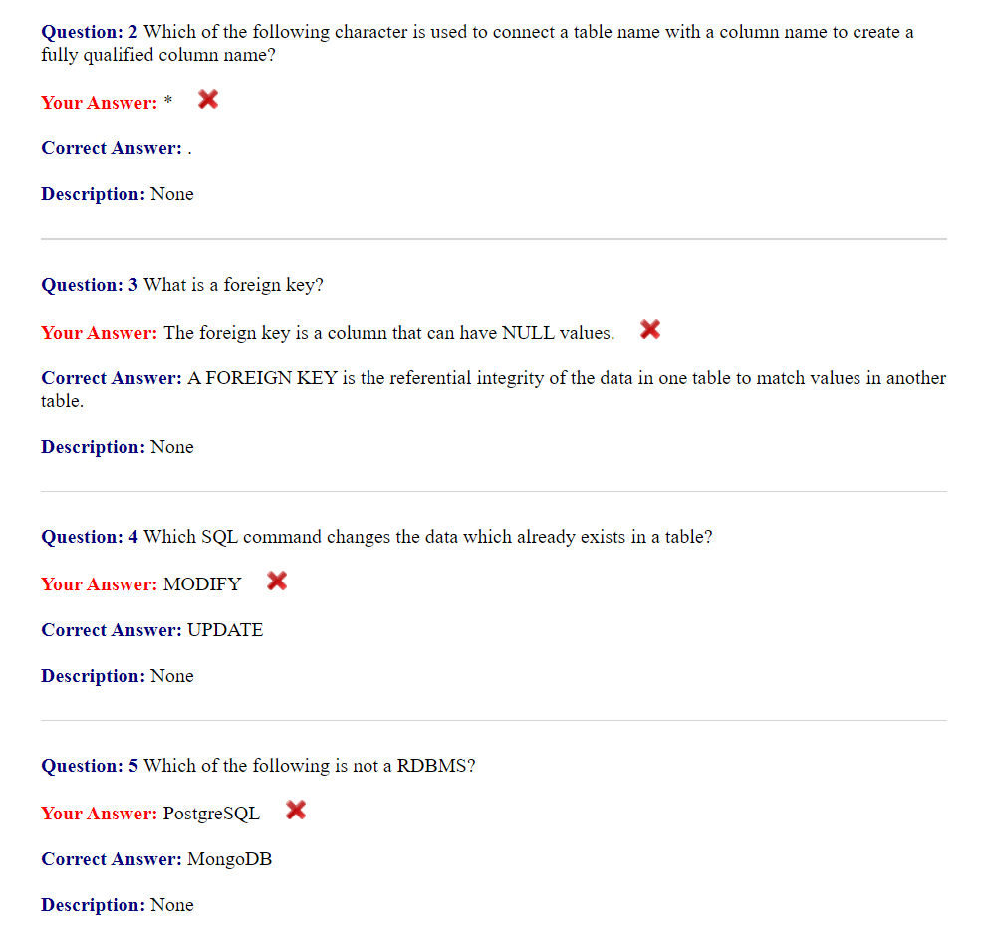

INSERT type query add new information into the database

JOIN used to merge two tables based on matching column

SELECT get information from database

DELETE remove information from database

GROUPE BY used to group your result by column value

SET update query to modify the exiting value

WHERE use to before adding condition to your query

DATABASE – any collection of related information like shopping list….

C.R.U.D – Create, Read, Update, Delete

Whenever we creating a table in relational database we always want to have a special column which is called primary key. Primary key is an attribute which uniquely defines the row in database.

In a table if 2 row have a same data but it’s both row have a different primary key. So that we can differencent b/w two row

Surrogate key is a basically key that has no mapping to anything in the real world

natural key is a basically key that has a mapping to anything in the real world. Just like social security number.

Foreign key stores the primary key of a row in another database table.

Foreign key is just a way that we can define relations b/w two table

Composite key

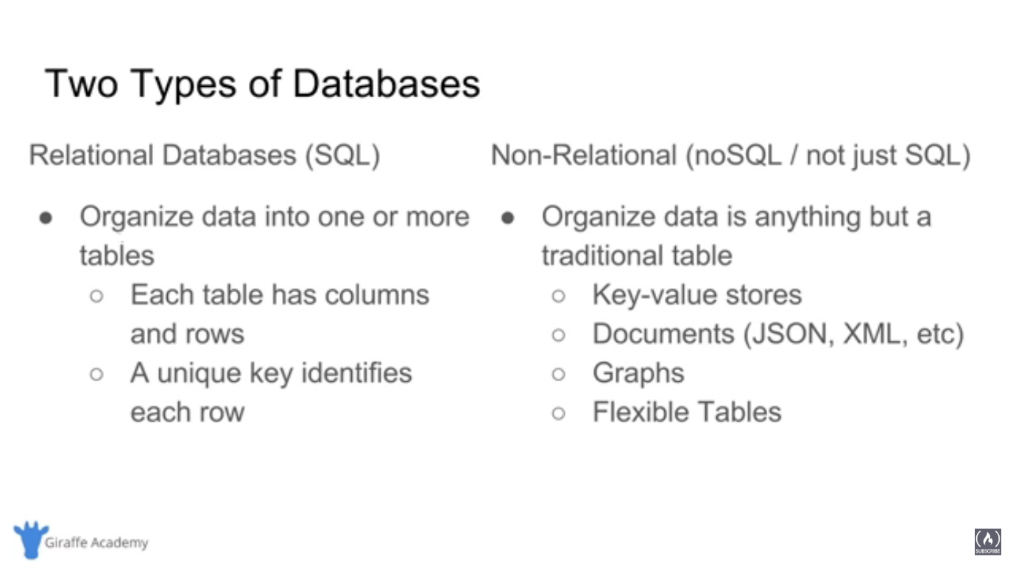

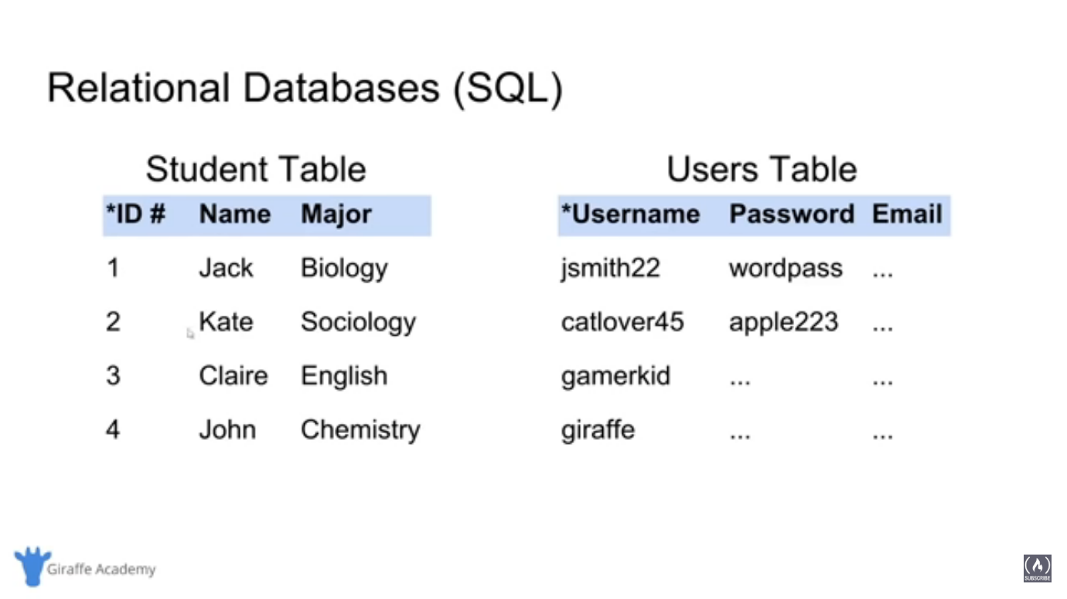

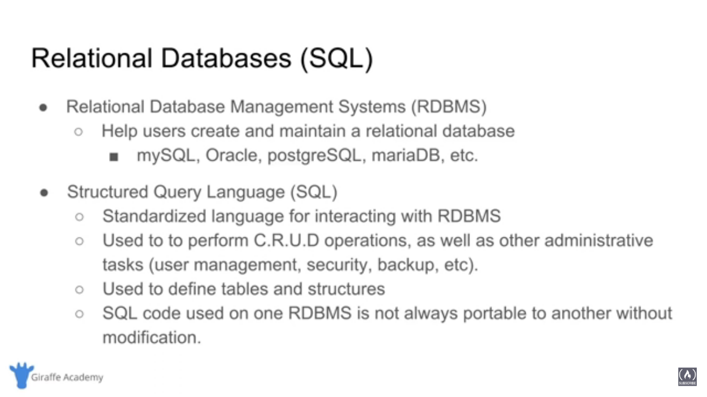

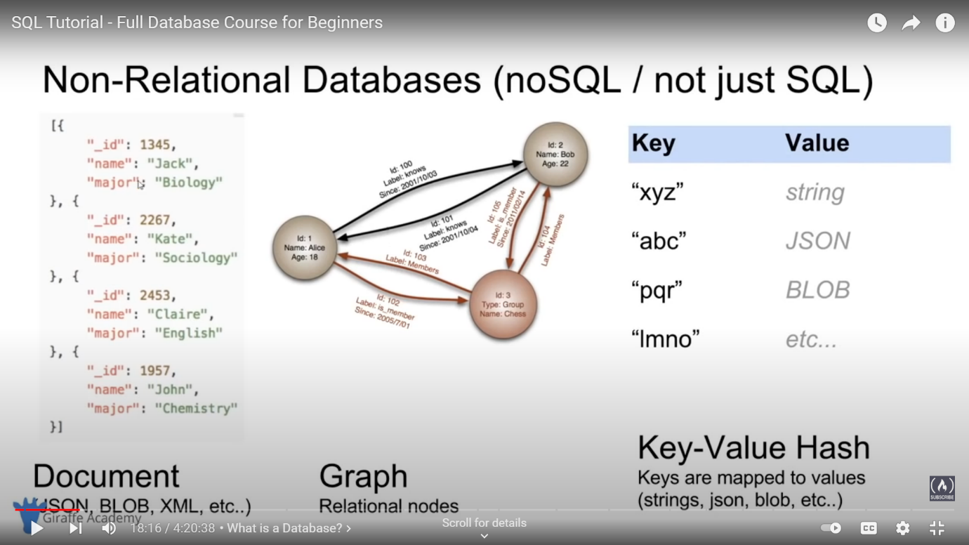

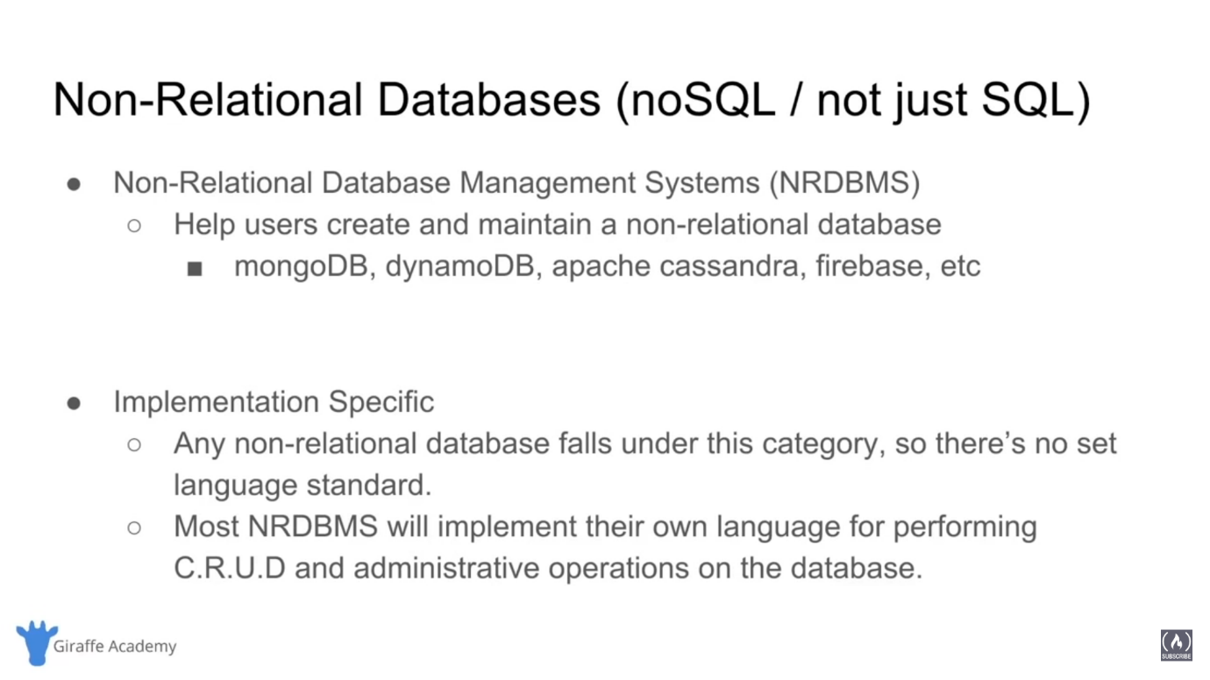

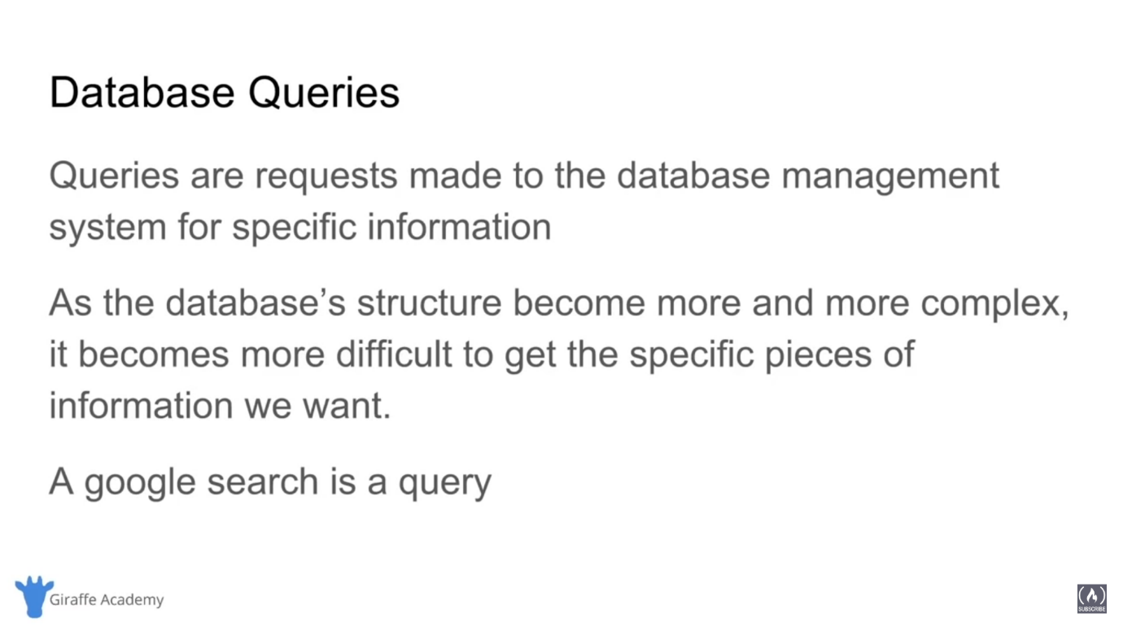

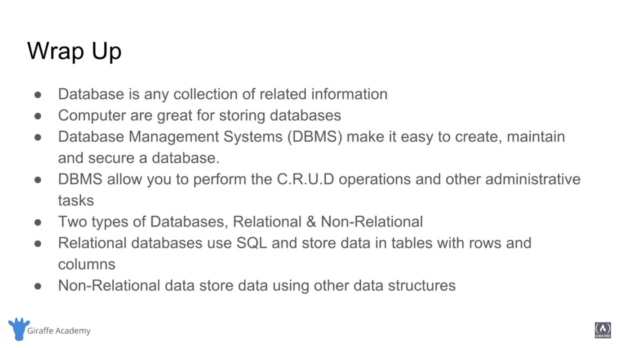

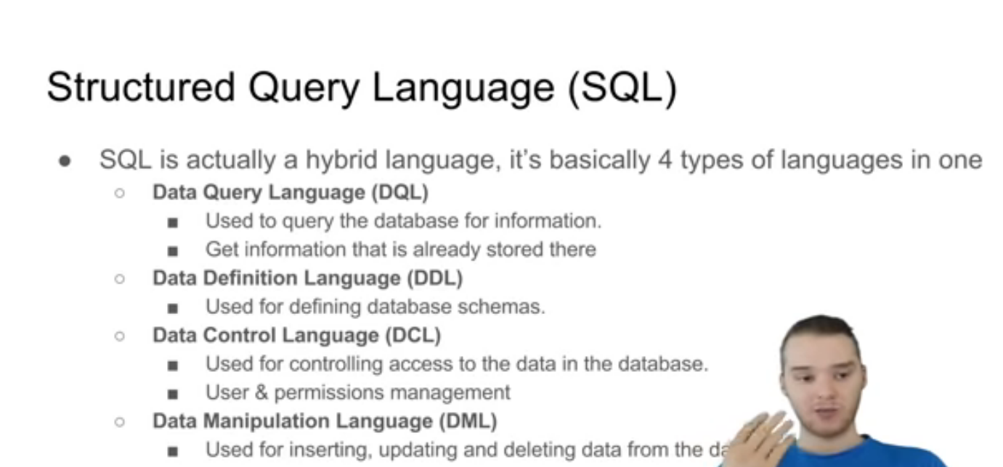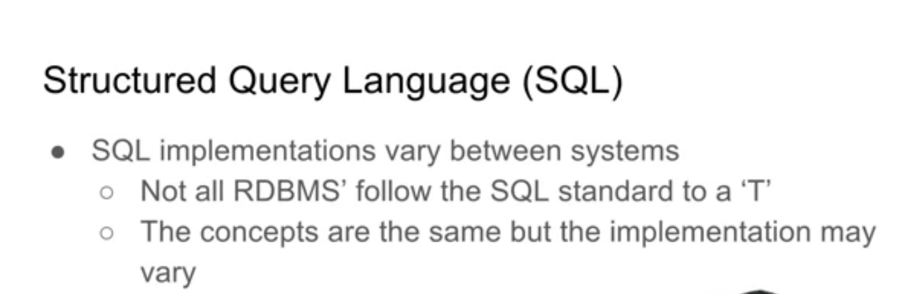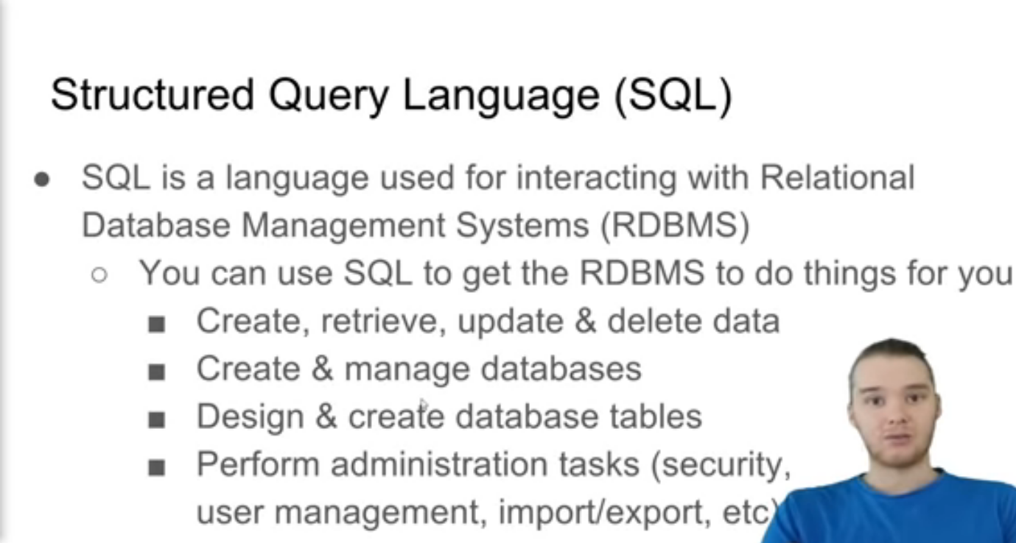

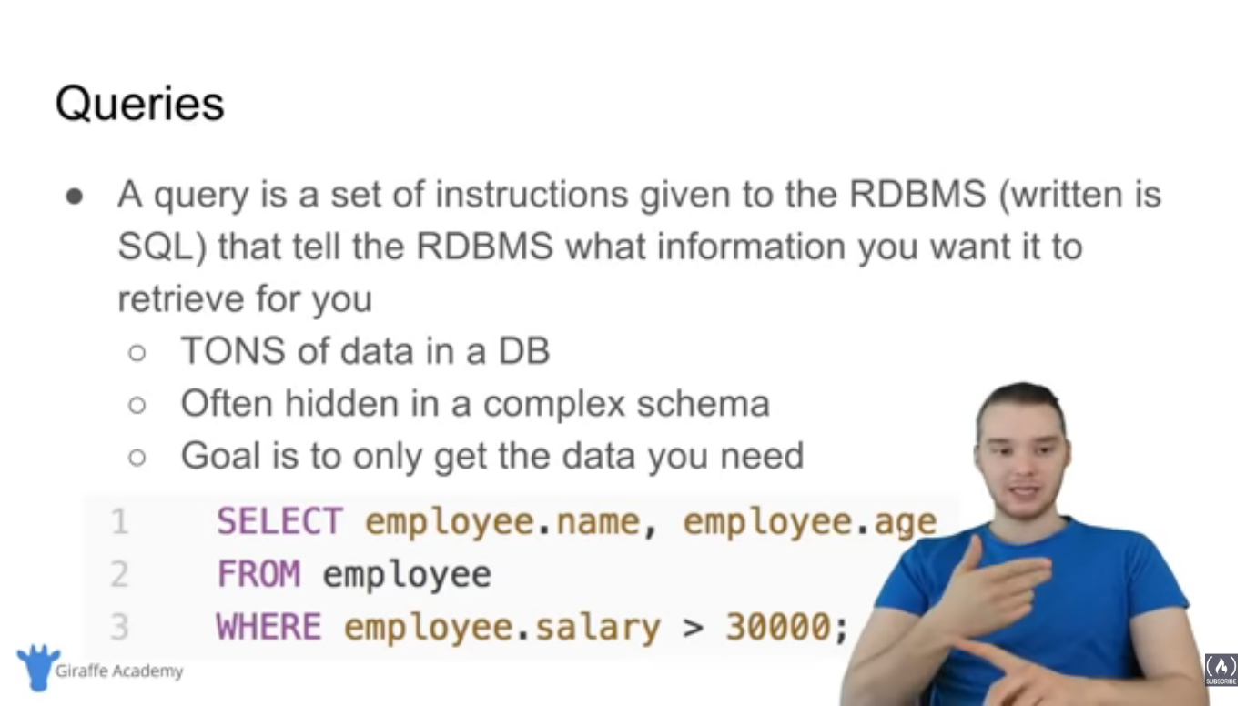

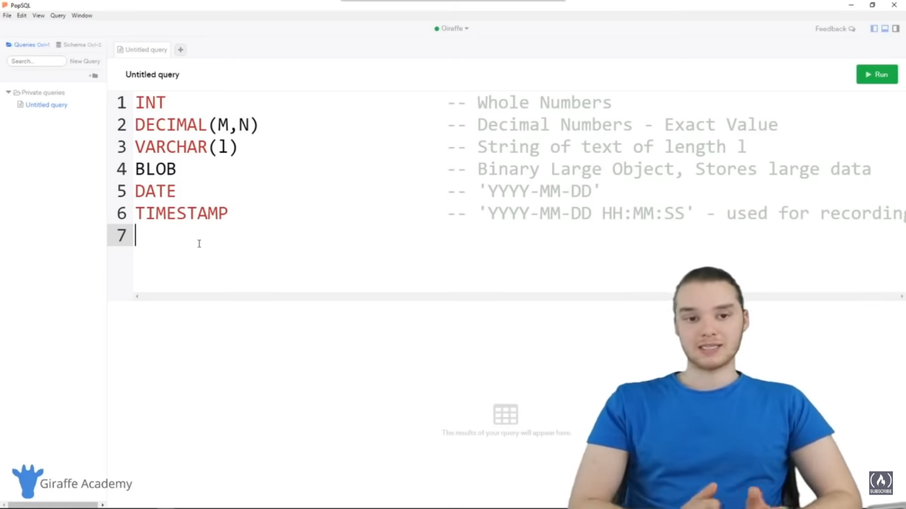

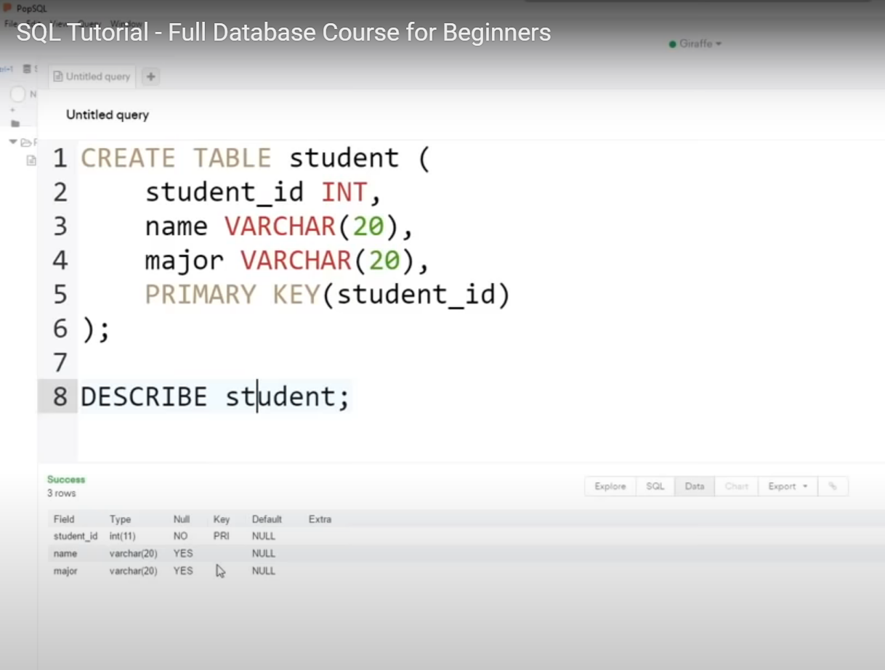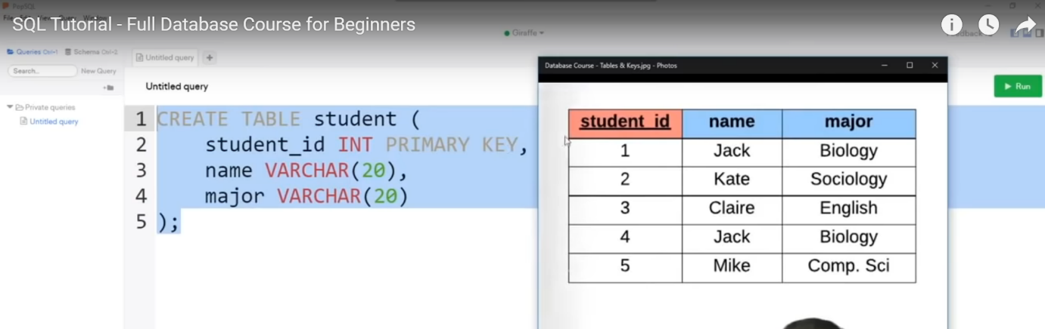

CREATE TABLE student(

student_id INT PRIMARY KEY,

name VARCHAR(20),

major VARCHAR(20)

);

SELECT * FROM student;

INSERT INTO student VALUES(1, 'Jack', 'biology');

INSERT INTO student(student_id, name) VALUES(1, 'Jack');

CREATE TABLE student(

student_id INT PRIMARY KEY,

name VARCHAR(20) NOT NULL,

major VARCHAR(20) UNIQUE

);

SELECT * FROM student;

INSERT INTO student VALUES(1, 'Null', 'biology');

It’s give error because name would not be null

CREATE TABLE student(

student_id INT PRIMARY KEY,

name VARCHAR(20),

major VARCHAR(20)

);

SELECT * FROM student;

INSERT INTO student VALUES(1, 'Jack', 'biology');

INSERT INTO student VALUES(1, 'Ram', 'biology');

It’s give error because major is unique and in this case we already define biology major

SELECT * FROM student;

UPDATE student

SET major = 'bio'

where major = 'biology';

ya phir WHERE student_id = 4;

ya phir WHERE major = ‘biology’ OR major = ‘science’;

ya phir SET name = ‘rahul’ , major = ‘bio’

WHERE student_id = 4;

DELEATE FROM student

WHERE student_id = 5;

Ya phir WHERE name = ‘tom’ AND major = ‘bio’;

SELECT * FROM = it’s means (*) select all column from the table

BASICS QUERY

SELECT name

FROM student; - it’s select all the names from student

SELECT *

FROM student

ORDER BY student_id ASC;

Ya ORDER BY student_id DESC;

YA ORDER BY major, student_id; so it’s first correct order of major( acc to alphabet) and then student id order

Ya LIMIT 2; = so It’s give only 2 column

<>not equal to

DISTINCT

SELECT COUNT(empl_id)

FROM employee;

Q find the no. of female employee born after 1978

SELECT COUNT(empl_id)

FROM employee

WHERE sex = ‘F’ AND birth_date > ‘1978-01-01’;

Q find the average salary of all employee

SELECT AVG(salary)

FROM employee;

Wildcards are basically a way to defining different patterns that we want to match specific pieces of data to.

LIKE keyboard use with wildcard

% = any # character _ = one character

Q find any client who are LLC

SELECT *

FROM client

WHERE client_name LIKE ‘%LLC’;

Q fine any employee born in October

SELECT *

FROM employee

WHERE birth_date LIKE ‘____-10%’; ____ = 4 TIME USE OF _ because year in 4

digits

UNION – we can use to combine the results of multiple select statement into one

Q find the list of employee and branch names

Ans SELECT first_name

FROM employee

UNION

SELECT branch_name

FROM branch;

JOIN – combine rows from two or more tables based on related column between them.

LEFT JOIN – means all of the row in the ‘employee’ table are going to get include in results

RIGHT JOIN – get all the branch

Nested query – a query where we going to using multiple select statements in order to get specific piece of information.

Q find name of all employee who have sold over 30000 to a single client

Ans SELECT employee.first_name, employee.last_name

FROM employee

WHERE employee.emp_id IN (

SELECT work_with.emp_id

FROM work_with

WHERE work_with.total_salary>30000

);

ON DELEATE SET NULL basically if we delete one of these employee that means manager id that was associated to that employee is going to get NULL

Trigger

ER diagram

ER – entity relationship

Entity – a object we want to model & store information about

|  |
| --- |
| student |

ER diagram act as middleman b/w database or storage requirements and actual database schema that going to get implemented in database management system

Attribute – specific piece of information about entity

Primary key – an attribute that uniquely identify an entry in the database type

Composite attribute – an attribute that can be broken up into the sub attribute

Multi-valued attribute – an attribute that can have more than one value

Derived attribute - an attribute that can be derived from the other attribute

Multiple entity – you can define more than one entity in the diagram

In relation if we use single line this indicate partial participation

Double line this indicate total participation

Relationship cardinality – the no. of instances of an entity from a relation that can be associated with the relation

Weak entity - an entity that cannot be uniquely identify by it’s attribute alone

Identifying relationship- a relationship that serves to uniquely identify the weak entity

1 Find all the WALL-* movies

SELECt title FROM movies

WHERE title LIKE "WALL-_%"

2 List all directors of Pixar movies (alphabetically), without duplicates

SELECT DISTINCT director FROM movies

ORDER BY director ASC;

3 List the last four Pixar movies released (ordered from most recent to least)

SELECT title, year FROM movies

ORDER BY year DESC

LIMIT 4;

4 List the **next** five Pixar movies sorted alphabetically

SELECT title FROM movies

ORDER BY title ASC

LIMIT 5 OFFSET 5;

5 List all the cities west of Chicago, ordered from west to east

SELECT city, longitude FROM north_american_cities

WHERE longitude < -87.629798

ORDER BY longitude ASC;

6 List the third and fourth largest cities (by population) in the United States and their population

SELECT city, population FROM north_american_cities

WHERE country LIKE "United States"

ORDER BY population DESC

LIMIT 2 OFFSET 2;

7 Find the domestic and international sales for each movie

SELECT title, domestic_sales, international_sales

FROM movies

JOIN boxoffice

ON movies.id = boxoffice.movie_id;

8 List all buildings and the distinct employee roles in each building (including empty buildings)

SELECT DISTINCT building_name, role

FROM buildings

LEFT JOIN employees

ON building_name = building;

9 Find the names of the buildings that hold no employees

SELECT DISTINCT building_name

FROM buildings

LEFT JOIN employees

ON building_name = building

WHERE role IS NULL;

10 List all movies and their combined sales in **millions** of dollars

SELECT title, (domestic_sales + international_sales) / 1000000 AS gross_sales_millions

FROM movies

JOIN boxoffice

ON movies.id = boxoffice.movie_id;

11List all movies that were released on even number years

SELECT title, year

FROM movies

WHERE year % 2 = 0;

12 Find the longest time that an employee has been at the studio

SELECT MAX(years_employed) as Max_years_employed

FROM employees;

13 For each role, find the average number of years employed by employees in that role

SELECT role, AVG(years_employed) as Average_years_employed

FROM employees

GROUP BY role;

14 Find the total number of employee years worked in each building

SELECT building, SUM(years_employed) as Total_years_employed

FROM employees

GROUP BY building;

15 Find the number of Artists in the studio (without a **HAVING** clause)

SELECT role, COUNT(*) as Number_of_artists

FROM employees

WHERE role = "Artist";

16 Find the total number of years employed by all Engineers

SELECT role, SUM(years_employed)

FROM employees

GROUP BY role

HAVING role = "Engineer";

SELECT DISTINCT column, AGG_FUNC(*column_or_expression*), …

FROM mytable

JOIN another_table

ON mytable.column = another_table.column

WHERE *constraint_expression*

GROUP BY column

HAVING *constraint_expression*

ORDER BY *column* ASC/DESC

LIMIT *count* OFFSET *COUNT*;

17 Toy Story 4 has been released to critical acclaim! It had a rating of **8.7**, and made **340 million domestically** and **270 million internationally**. Add the record to the **BoxOffice** table.

INSERT INTO boxoffice VALUES (4, 8.7, 340000000, 270000000);

18 The director for A Bug's Life is incorrect, it was actually directed by **John Lasseter**

UPDATE movies

SET director = "John Lasseter"

WHERE id = 2;

19 Add a column named **Aspect_ratio** with a **FLOAT** data type to store the aspect-ratio each movie was released in.

ALTER TABLE Movies

ADD COLUMN Aspect_ratio FLOAT DEFAULT 2.39;